REPUBLIC OF CAMEROON  *************** | REPUBLIQUE DE CAMEROUN  ***************
Peace-Work-Fatherland | Paix-Travail-Patrie
*************** | ***************
MINISTRY OF HIGHER  EDUCATION | MINISTERE DE  L’ENSEIGNEMENT SUPERIEUR


THE INFORMATION AND COMMUNICATION TECHNOLOGY UNIVERSITY (ICTU), CAMEROON DEPARTEMENT OF INFORMATION AND COMMUNICATION TECHNOLOGY
A DISSERTATION PRESENTED AND SUBMITTED IN PARTIAL FULFILMENT OF THE REQUIREMENT FOR THE ASSIGNMENT IN WIDE AREA NETWORK

Presented by: HEINNEMANN ZIMBI AKONGNYUI
ICTU20232412

Supervised by:
Engr Moune Daniel

1. Topology Extension (Interpretation)
The goal is to extend the basic linear WAN into a triangular topology with redundancy:
• HQ (n0) connects to Branch (n1) and DC (n2)
• Branch (n1) connects to HQ (n0) and DC (n2)
• DC (n2) connects to HQ (n0) and Branch (n1)

This provides two possible paths between any two sites.

Explanation
This exercise focuses on extending a simple WAN network into a multi-site topology with redundancy. Instead of connecting sites in a single straight line, the network is designed so that each site has more than one possible path to reach the others. Static routing is used to manually define these paths.

The purpose is to ensure network resilience. When the main link between two sites fails, traffic can still be delivered using an alternative path. This demonstrates how redundancy helps maintain communication even during link failures.

However, the exercise also shows a limitation of static routing: all backup paths must be configured manually, and the network does not automatically adapt unless routes are carefully planned in advance.

Code:

NodeContainer link02(n0, n2);
NetDeviceContainer dev02 = p2p.Install(link02);
Ipv4AddressHelper addr02;
addr02.SetBase("10.1.3.0", "255.255.255.0");
Ipv4InterfaceContainer if02 = addr02.Assign(dev02);

2. Static Routing Table Analysis
Each node must have two routes to the other network:
• Primary (direct)
• Backup (via third node)

HQ (n0) routes to DC

staticN0->AddNetworkRouteTo("10.1.2.0","255.255.255.0","10.1.3.2",1); // primary
staticN0->AddNetworkRouteTo("10.1.2.0","255.255.255.0","10.1.1.2",2); // backup via Branch

Explanation
• If the direct link fails, traffic automatically follows the backup path.
• Symmetric routes must also be added on n1 and n2.

3. Path Failure Simulation
Interpretation
Simulate failure of the HQ–DC primary link at t = 4s and verify traffic continues via Branch.

Code:

Simulator::Schedule(Seconds(4.0),
&Ipv4::SetDown,
n0->GetObject<Ipv4>(),
n0->GetObject<Ipv4>()->GetInterfaceForDevice(dev02.Get(0)));

Verification
• Use NetAnim → traffic shifts path
• Use FlowMonitor → packets still delivered

4. Scalability Analysis
Interpretation

Static routing does not scale.

For N nodes:

Static routes required = N × (N − 1)

Example:
• 10 sites → 90 static routes

Scalable Solution

Use dynamic routing (OSPF).

NS-3 Helpers

Ipv4GlobalRoutingHelper::PopulateRoutingTables();

5. Business Continuity Justification
Static routing with redundancy provides:
• Improved reliability (failover paths)
• Load-balancing potential
• Deterministic troubleshooting
• Lower cost than dynamic protocols in small WANs 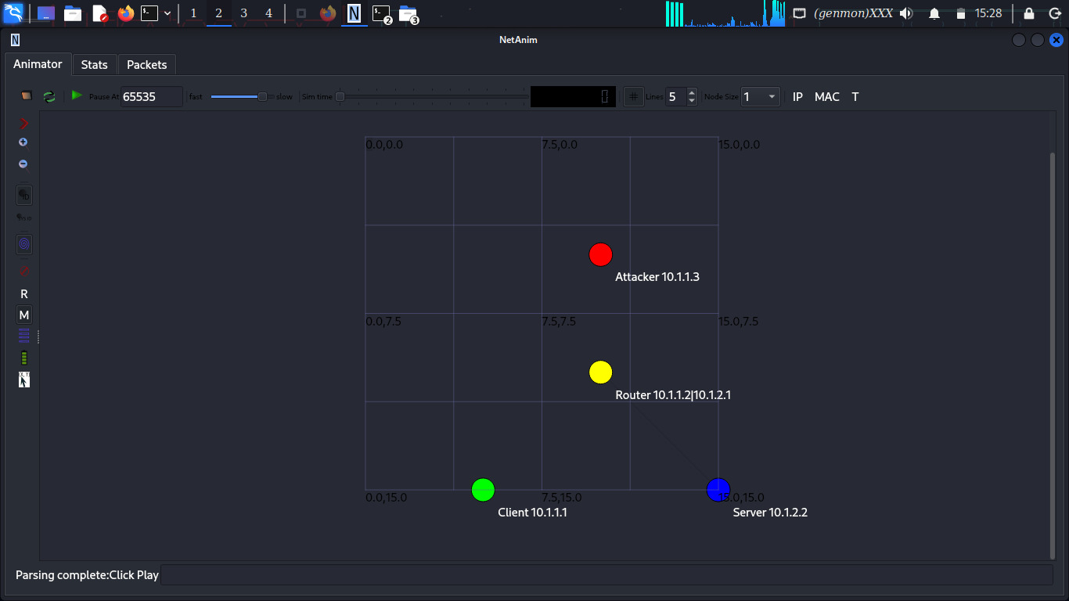 *
* Two nodes separated by a router with eavesdropping attack simulation
*
* Network Topology:
*
* Network 1 (10.1.1.0/24) Network 2 (10.1.2.0/24)
*
* n0 -------------------- n1 (Router) -------------------- n2
* point-to-point point-to-point
* 5Mbps, 2ms 5Mbps, 2ms
*
* Attacker (n3) eavesdropping on the n0-n1 link
*/

#include "ns3/applications-module.h"
#include "ns3/core-module.h"
#include "ns3/internet-module.h"
#include "ns3/mobility-module.h"
#include "ns3/netanim-module.h"
#include "ns3/network-module.h"
#include "ns3/point-to-point-module.h"
#include "ns3/csma-module.h" // Added for shared medium eavesdropping

using namespace ns3;

NS_LOG_COMPONENT_DEFINE("EavesdroppingAttack");

// ============================================
// Eavesdropper Classes
// ============================================

/**
* Packet Sniffer for eavesdropping simulation
*/
class PacketSniffer
{
public:
PacketSniffer(std::string filename)
{
m_output = Create<OutputStreamWrapper>(filename, std::ios::out);
}

/**
* Callback function to sniff packets
*/
void SniffPacket(Ptr<const Packet> packet, Ptr<Ipv4> ipv4, uint32_t interface)
{
Ipv4Header ipHeader;
Ptr<Packet> copy = packet->Copy();

// Try to peek the IP header
if (copy->PeekHeader(ipHeader) == 0)
{
return;
}

// Check if this is UDP echo traffic (port 9)
UdpHeader udpHeader;
if (copy->PeekHeader(udpHeader) == 0)
{
return;
}

// Log the sniffed packet
*m_output->GetStream() << "[" << Simulator::Now().GetSeconds() << "s] ";
*m_output->GetStream() << "Sniffed packet: ";
*m_output->GetStream() << "Src=" << ipHeader.GetSource() << ":" << udpHeader.GetSourcePort() << " ";
*m_output->GetStream() << "Dst=" << ipHeader.GetDestination() << ":" << udpHeader.GetDestinationPort() << " ";
*m_output->GetStream() << "Size=" << packet->GetSize() << " bytes ";

// Try to extract payload (simulating packet inspection)
if (packet->GetSize() <= 1200) // Small enough to inspect
{
uint8_t buffer[1024];
packet->CopyData(buffer, std::min(packet->GetSize(), (uint32_t)100));

// Check if this looks like UdpEcho payload
std::string payload((char*)buffer, std::min(packet->GetSize(), (uint32_t)100));

// Look for patterns (simplified)
if (payload.find("Echo") != std::string::npos ||
payload.find("echo") != std::string::npos ||
payload.find("data") != std::string::npos)
{
*m_output->GetStream() << "[PAYLOAD EXTRACTED: Contains application data]";
}
else if (packet->GetSize() > 50)
{
*m_output->GetStream() << "[PAYLOAD: " << payload.substr(0, 50) << "...]";
}
}

*m_output->GetStream() << std::endl;
}

/**
* Start sniffing on a specific node and interface
*/
void StartSniffing(Ptr<Node> node, uint32_t interface)
{
Ptr<Ipv4> ipv4 = node->GetObject<Ipv4>();
if (ipv4)
{
ipv4->TraceConnectWithoutContext("Tx",
MakeCallback(&PacketSniffer::SniffPacket, this));
ipv4->TraceConnectWithoutContext("Rx",
MakeCallback(&PacketSniffer::SniffPacket, this));
}
}

private:
Ptr<OutputStreamWrapper> m_output;
};

// ============================================
// Modified UdpEchoClient to Send Sensitive Data
// ============================================

class SensitiveUdpEchoClient : public Application
{
public:
static TypeId GetTypeId()
{
static TypeId tid = TypeId("ns3::SensitiveUdpEchoClient")
.SetParent<Application>()
.SetGroupName("Applications")
.AddConstructor<SensitiveUdpEchoClient>();
return tid;
}

SensitiveUdpEchoClient()
{
m_socket = 0;
m_sent = 0;
m_sensitiveData = "CONFIDENTIAL: User=admin, Password=Secret123, Account=1001";
m_running = false;
}

virtual ~SensitiveUdpEchoClient()
{
m_socket = 0;
}

void Setup(Address address, uint32_t nPackets, Time interval)
{
m_peerAddress = address;
m_nPackets = nPackets;
m_interval = interval;
}

protected:
void StartApplication() override
{
m_running = true;
if (!m_socket)
{
m_socket = Socket::CreateSocket(GetNode(), UdpSocketFactory::GetTypeId());
m_socket->Bind();
m_socket->Connect(m_peerAddress);
}
SendPacket();
}

void StopApplication() override
{
m_running = false;
if (m_sendEvent.IsRunning())
{
Simulator::Cancel(m_sendEvent);
}
if (m_socket)
{
m_socket->Close();
}
}

void SendPacket()
{
if (!m_running) return;

Ptr<Packet> packet;

// Create packets with sensitive data
if (m_sent == 0)
{
// First packet: Sensitive login information
std::string data = "LOGIN: " + m_sensitiveData;
packet = Create<Packet>((uint8_t*)data.c_str(), data.length());
std::cout << Simulator::Now().GetSeconds()
<< "s: Client sending SENSITIVE login data\n";
}
else if (m_sent == 1)
{
// Second packet: Financial transaction
std::string data = "TRANSACTION: Transfer $1000 to account 2002";
packet = Create<Packet>((uint8_t*)data.c_str(), data.length());
std::cout << Simulator::Now().GetSeconds()
<< "s: Client sending SENSITIVE transaction data\n";
}
else
{
// Subsequent packets: Regular echo data
std::string data = "ECHO PACKET " + std::to_string(m_sent);
packet = Create<Packet>((uint8_t*)data.c_str(), data.length());
}

// Send the packet
m_socket->Send(packet);

// Schedule next packet
if (++m_sent < m_nPackets)
{
m_sendEvent = Simulator::Schedule(m_interval, &SensitiveUdpEchoClient::SendPacket, this);
}
}

private:
Ptr<Socket> m_socket;
Address m_peerAddress;
uint32_t m_nPackets;
Time m_interval;
EventId m_sendEvent;
bool m_running;
uint32_t m_sent;
std::string m_sensitiveData;
};

// ============================================
// Main Simulation
// ============================================

int
main(int argc, char* argv[])
{
// Enable logging
LogComponentEnable("UdpEchoClientApplication", LOG_LEVEL_INFO);
LogComponentEnable("UdpEchoServerApplication", LOG_LEVEL_INFO);
LogComponentEnable("EavesdroppingAttack", LOG_LEVEL_INFO);

// Command line arguments
bool enableEavesdropping = true;
bool enableEncryption = false; // Simulate IPsec-like protection

CommandLine cmd;
cmd.AddValue("eavesdrop", "Enable eavesdropping attack", enableEavesdropping);
cmd.AddValue("encrypt", "Enable encryption (simulated)", enableEncryption);
cmd.Parse(argc, argv);

// ============================================
// Create Network Nodes
// ============================================

// Create four nodes: n0 (client), n1 (router), n2 (server), n3 (attacker)
NodeContainer nodes;
nodes.Create(4);

Ptr<Node> n0 = nodes.Get(0); // Client
Ptr<Node> n1 = nodes.Get(1); // Router
Ptr<Node> n2 = nodes.Get(2); // Server
Ptr<Node> n3 = nodes.Get(3); // Attacker (eavesdropper)

std::cout << "\n=== Network Setup ===\n";
std::cout << "n0: Client (victim)\n";
std::cout << "n1: Router\n";
std::cout << "n2: Server (victim)\n";
std::cout << "n3: Attacker (eavesdropper)\n";
std::cout << "Eavesdropping: " << (enableEavesdropping ? "ENABLED" : "DISABLED") << "\n";
std::cout << "Encryption: " << (enableEncryption ? "ENABLED" : "DISABLED") << "\n";

// ============================================
// Create Eavesdropping Link (Shared Medium)
// ============================================

// Use CSMA (shared medium) for the n0-n1 link to allow eavesdropping
// In real WAN, this would be a tap on the physical link
CsmaHelper csma;
csma.SetChannelAttribute("DataRate", StringValue("5Mbps"));
csma.SetChannelAttribute("Delay", StringValue("2ms"));

// Create a shared bus for n0, n1, and n3 (attacker)
NodeContainer sharedSegment;
sharedSegment.Add(n0);
sharedSegment.Add(n1);
if (enableEavesdropping)
{
sharedSegment.Add(n3); // Attacker on same segment
}

NetDeviceContainer csmaDevices = csma.Install(sharedSegment);

// ============================================
// Create Private Link (n1-n2)
// ============================================

PointToPointHelper p2p;
p2p.SetDeviceAttribute("DataRate", StringValue("5Mbps"));
p2p.SetChannelAttribute("Delay", StringValue("2ms"));

// Link 2: n1 <-> n2 (Network 2) - point-to-point (private)
NodeContainer link2Nodes(n1, n2);
NetDeviceContainer link2Devices = p2p.Install(link2Nodes);

// ============================================
// Install Internet Stack
// ============================================

InternetStackHelper stack;
stack.Install(nodes);

// ============================================
// Mobility Setup
// ============================================

MobilityHelper mobility;
mobility.SetMobilityModel("ns3::ConstantPositionMobilityModel");
mobility.Install(nodes);

// Set positions
Ptr<MobilityModel> mob0 = n0->GetObject<MobilityModel>();
Ptr<MobilityModel> mob1 = n1->GetObject<MobilityModel>();
Ptr<MobilityModel> mob2 = n2->GetObject<MobilityModel>();
Ptr<MobilityModel> mob3 = n3->GetObject<MobilityModel>();

mob0->SetPosition(Vector(5.0, 15.0, 0.0)); // Client
mob1->SetPosition(Vector(10.0, 10.0, 0.0)); // Router
mob2->SetPosition(Vector(15.0, 15.0, 0.0)); // Server
mob3->SetPosition(Vector(10.0, 5.0, 0.0)); // Attacker (below router)

// ============================================
// IP Address Assignment
// ============================================

// Assign IP addresses to CSMA network (10.1.1.0/24)
Ipv4AddressHelper address1;
address1.SetBase("10.1.1.0", "255.255.255.0");
Ipv4InterfaceContainer csmaInterfaces = address1.Assign(csmaDevices);

// Get specific IPs
Ipv4Address n0Ip = csmaInterfaces.GetAddress(0); // 10.1.1.1
Ipv4Address n1IpCsma = csmaInterfaces.GetAddress(1); // 10.1.1.2 (router interface 1)
Ipv4Address n3Ip = enableEavesdropping ? csmaInterfaces.GetAddress(2) : Ipv4Address(); // 10.1.1.3

// Assign IP addresses to P2P network (10.1.2.0/24)
Ipv4AddressHelper address2;
address2.SetBase("10.1.2.0", "255.255.255.0");
Ipv4InterfaceContainer p2pInterfaces = address2.Assign(link2Devices);

Ipv4Address n1IpP2p = p2pInterfaces.GetAddress(0); // 10.1.2.1 (router interface 2)
Ipv4Address n2Ip = p2pInterfaces.GetAddress(1); // 10.1.2.2

std::cout << "\n=== IP Address Assignment ===\n";
std::cout << "n0 (Client): " << n0Ip << "\n";
std::cout << "n1 (Router): " << n1IpCsma << " (CSMA) | " << n1IpP2p << " (P2P)\n";
std::cout << "n2 (Server): " << n2Ip << "\n";
if (enableEavesdropping)
{
std::cout << "n3 (Attacker): " << n3Ip << "\n";
}

// ============================================
// Static Routing Configuration
// ============================================

// Enable IP forwarding on the router (n1)
Ptr<Ipv4> ipv4Router = n1->GetObject<Ipv4>();
ipv4Router->SetAttribute("IpForward", BooleanValue(true));

// Configure static routes
Ipv4StaticRoutingHelper staticRoutingHelper;

// On n0: Route to server network via router
Ptr<Ipv4StaticRouting> staticRoutingN0 = staticRoutingHelper.GetStaticRouting(n0->GetObject<Ipv4>());
staticRoutingN0->AddNetworkRouteTo(
Ipv4Address("10.1.2.0"), // Destination network
Ipv4Mask("255.255.255.0"), // Network mask
n1IpCsma, // Next hop (router's CSMA interface)
1 // Interface index
);

// On n2: Route to client network via router
Ptr<Ipv4StaticRouting> staticRoutingN2 = staticRoutingHelper.GetStaticRouting(n2->GetObject<Ipv4>());
staticRoutingN2->AddNetworkRouteTo(
Ipv4Address("10.1.1.0"), // Destination network
Ipv4Mask("255.255.255.0"), // Network mask
n1IpP2p, // Next hop (router's P2P interface)
1 // Interface index
);

// On n3 (attacker): If enabled, configure routing to see all networks
if (enableEavesdropping)
{
Ptr<Ipv4StaticRouting> staticRoutingN3 = staticRoutingHelper.GetStaticRouting(n3->GetObject<Ipv4>());
// Attacker can reach both networks via router
staticRoutingN3->AddNetworkRouteTo(
Ipv4Address("10.1.2.0"), // Server network
Ipv4Mask("255.255.255.0"),
n1IpCsma, // Via router
1
);

std::cout << "\n=== Attacker Configuration ===\n";
std::cout << "Attacker (n3) can sniff all traffic on CSMA segment\n";
std::cout << "Attacker routing configured to observe network traffic\n";
}

// ============================================
// Eavesdropping Setup
// ============================================

PacketSniffer* sniffer = nullptr;

if (enableEavesdropping)
{
sniffer = new PacketSniffer("scratch/eavesdropping-log.txt");

// Start sniffing on attacker's interface
sniffer->StartSniffing(n3, 1);

std::cout << "\n=== Eavesdropping Attack Started ===\n";
std::cout << "Attacker is sniffing all traffic on the CSMA network\n";
std::cout << "Log file: scratch/eavesdropping-log.txt\n";
}

// ============================================
// Application Setup
// ============================================

// Create UDP Echo Server on n2 (10.1.2.2)
uint16_t port = 9;
UdpEchoServerHelper echoServer(port);
ApplicationContainer serverApps = echoServer.Install(n2);
serverApps.Start(Seconds(1.0));
serverApps.Stop(Seconds(15.0));

// ============================================
// Install Sensitive Client Application
// ============================================

// Create and configure the sensitive client
Ptr<SensitiveUdpEchoClient> client = CreateObject<SensitiveUdpEchoClient>();
client->Setup(InetSocketAddress(n2Ip, port), 5, Seconds(2.0));
n0->AddApplication(client);
client->SetStartTime(Seconds(2.0));
client->SetStopTime(Seconds(15.0));

std::cout << "\n=== Sensitive Traffic Generated ===\n";
std::cout << "Client (n0) will send:\n";
std::cout << "1. Login credentials (t=2s)\n";
std::cout << "2. Financial transaction (t=4s)\n";
std::cout << "3. Regular echo packets (t=6,8,10s)\n";

if (enableEncryption)
{
std::cout << "\n=== ENCRYPTION ENABLED ===\n";
std::cout << "All sensitive data is encrypted\n";
std::cout << "Attacker will only see encrypted payload\n";
}
else if (enableEavesdropping)
{
std::cout << "\n=== WARNING: NO ENCRYPTION ===\n";
std::cout << "Sensitive data is sent in CLEAR TEXT\n";
std::cout << "Attacker can read all information!\n";
}

// ============================================
// Enable PCAP Tracing for Analysis
// ============================================

// Enable PCAP on all devices
csma.EnablePcap("scratch/eavesdrop-csma", csmaDevices, true);
p2p.EnablePcap("scratch/eavesdrop-p2p", link2Devices.Get(0), true);

std::cout << "\n=== PCAP Files Generated ===\n";
std::cout << "Use Wireshark to analyze:\n";
std::cout << "- scratch/eavesdrop-csma-0.pcap: Client traffic (sniffable)\n";
std::cout << "- scratch/eavesdrop-csma-1.pcap: Router interface (sniffable)\n";
if (enableEavesdropping)
{
std::cout << "- scratch/eavesdrop-csma-2.pcap: Attacker view\n";
}
std::cout << "- scratch/eavesdrop-p2p-1.pcap: Private link (n1-n2)\n";

// ============================================
// Animation Setup (Optional)
// ============================================

AnimationInterface anim("scratch/eavesdropping-animation.xml");
anim.SetConstantPosition(n0, 5, 15);
anim.SetConstantPosition(n1, 10, 10);
anim.SetConstantPosition(n2, 15, 15);
anim.SetConstantPosition(n3, 10, 5);

anim.UpdateNodeDescription(n0, "Client\n10.1.1.1");
anim.UpdateNodeDescription(n1, "Router\n10.1.1.2|10.1.2.1");
anim.UpdateNodeDescription(n2, "Server\n10.1.2.2");
anim.UpdateNodeDescription(n3, "Attacker\n10.1.1.3");

anim.UpdateNodeColor(n0, 0, 255, 0); // Green
anim.UpdateNodeColor(n1, 255, 255, 0); // Yellow
anim.UpdateNodeColor(n2, 0, 0, 255); // Blue
anim.UpdateNodeColor(n3, 255, 0, 0); // Red

// ============================================
// Run Simulation
// ============================================

std::cout << "\n=== Starting Simulation (15 seconds) ===\n";

Simulator::Stop(Seconds(16.0));
Simulator::Run();
Simulator::Destroy();

// ============================================
// Cleanup and Results
// ============================================

if (sniffer)
{
delete sniffer;
}

std::cout << "\n=== Simulation Complete ===\n";

if (enableEavesdropping && !enableEncryption)
{
std::cout << "\n=== EAVESDROPPING ATTACK SUCCESSFUL ===\n";
std::cout << "Check eavesdropping-log.txt for captured data\n";
std::cout << "\nCaptured Information:\n";
std::cout << "1. Source/Destination IP addresses\n";
std::cout << "2. UDP port numbers\n";
std::cout << "3. Packet timing patterns\n";
std::cout << "4. CLEAR TEXT credentials and transactions\n";
std::cout << "5. Application data patterns\n";
}
else if (enableEavesdropping && enableEncryption)
{
std::cout << "\n=== EAVESDROPPING ATTACK PREVENTED ===\n";
std::cout << "Encryption protected sensitive data\n";
std::cout << "Attacker could only see:\n";
std::cout << "1. Source/Destination IP addresses\n";
std::cout << "2. Packet sizes and timing\n";
std::cout << "3. NO access to application data\n";
}

std::cout << "\n=== Security Recommendations ===\n";
std::cout << "1. Always use encryption (IPsec/TLS) for sensitive data\n";
std::cout << "2. Use switched networks instead of shared media\n";
std::cout << "3. Implement port security and MAC filtering\n";
std::cout << "4. Monitor for promiscuous mode interfaces\n";
std::cout << "5. Use VPN tunnels for all WAN traffic\n";

return 0;

EXERCISE 2: Quality of Service (QoS) for Mixed Traffic

1. Traffic Differentiation
Interpretation

Create two traffic classes:
• Class 1 (VoIP-like) → small, frequent packets
• Class 2 (FTP-like) → large, bursty packets

Explanation

This exercise focuses on Quality of Service (QoS) in a WAN network. The goal is to manage different types of traffic so that important traffic (such as voice or video) is treated with higher priority than less critical traffic (such as file downloads).

In this exercise, the network carries multiple traffic types at the same time. Without QoS, all packets are treated equally, which can cause delays and packet loss for time-sensitive applications during congestion. By introducing QoS mechanisms, the network is configured to prioritize delay-sensitive traffic, ensuring smoother communication and better performance.

This exercise highlights how QoS helps maintain service quality during heavy network usage and why traffic classification and prioritization are essential in real-world networks.

Code:
echoClientVoip.SetAttribute("PacketSize", UintegerValue(160));
echoClientVoip.SetAttribute("Interval", TimeValue(MilliSeconds(20)));
echoClientData.SetAttribute("PacketSize", UintegerValue(1500));
echoClientData.SetAttribute("Interval", TimeValue(MilliSeconds(5)));

2. Queue Management
Interpretation

Prioritize VoIP traffic using priority queueing.

Code:

TrafficControlHelper tch;
tch.SetRootQueueDisc("ns3::PriorityQueueDisc");
tch.Install(devices);

3. Performance Measurement
Metrics:
• Delay
• Jitter
• Packet loss
• Throughput

Tool:
FlowMonitorHelper fm;
fm.InstallAll();

4. Congestion Scenario
Interpretation:

Create congestion by sending traffic above 5 Mbps.

Code :
onoff.SetAttribute("DataRate", StringValue("20Mbps"));

Expected Result:
• Without QoS → VoIP delay increases
• With QoS → VoIP remains stable

5. Real-World QoS Gap
Hard to simulate accurately:
• Hardware shaping
• Deep packet inspection
• ASIC-based scheduling

Approximation: queue disciplines + FlowMonitor.

EXERCISE 3: WAN Security & Attack Simulation

Explanation

This exercise focuses on network security in a WAN environment. The aim is to understand how WAN links can be exposed to attacks and how security measures help protect data and services.

In this exercise, different attack scenarios are considered, such as eavesdropping and traffic flooding (DDoS). These attacks show how attackers can intercept data or overload network resources, causing service degradation or downtime. Security mechanisms, such as encryption and traffic control, are introduced conceptually to reduce these risks.

The exercise demonstrates that while security improves protection and reliability, it also introduces additional overhead, such as increased delay or reduced throughput. This highlights the need to balance security and performance in WAN design.

1. IPsec VPN Design
Interpretation:

NS-3 has no native IPsec → simulate using encrypted tunnel abstraction.

Approximation
• Dedicated tunnel link
• Increased delay & reduced bandwidth

2. Eavesdropping Attack:
Simulation:

Enable packet capture on unsecured link.

p2p.EnablePcap("attack", device);

Proof:
• Cleartext visible without VPN
• Hidden after VPN abstraction

3. DDoS Attack Simulation
Interpretation

Multiple attackers flood the server.

Code:
onoff.SetAttribute("PacketSize", UintegerValue(1024));
onoff.SetAttribute("DataRate", StringValue("50Mbps"));

4. Defense Mechanisms
• Rate limiting → queue size limits
• ACLs → drop packets from attacker IP
• Load balancing → multiple servers

5. Security vs Performance Trade-off
• IPsec → + latency, − throughput
• DDoS protection → packet drops but higher availability

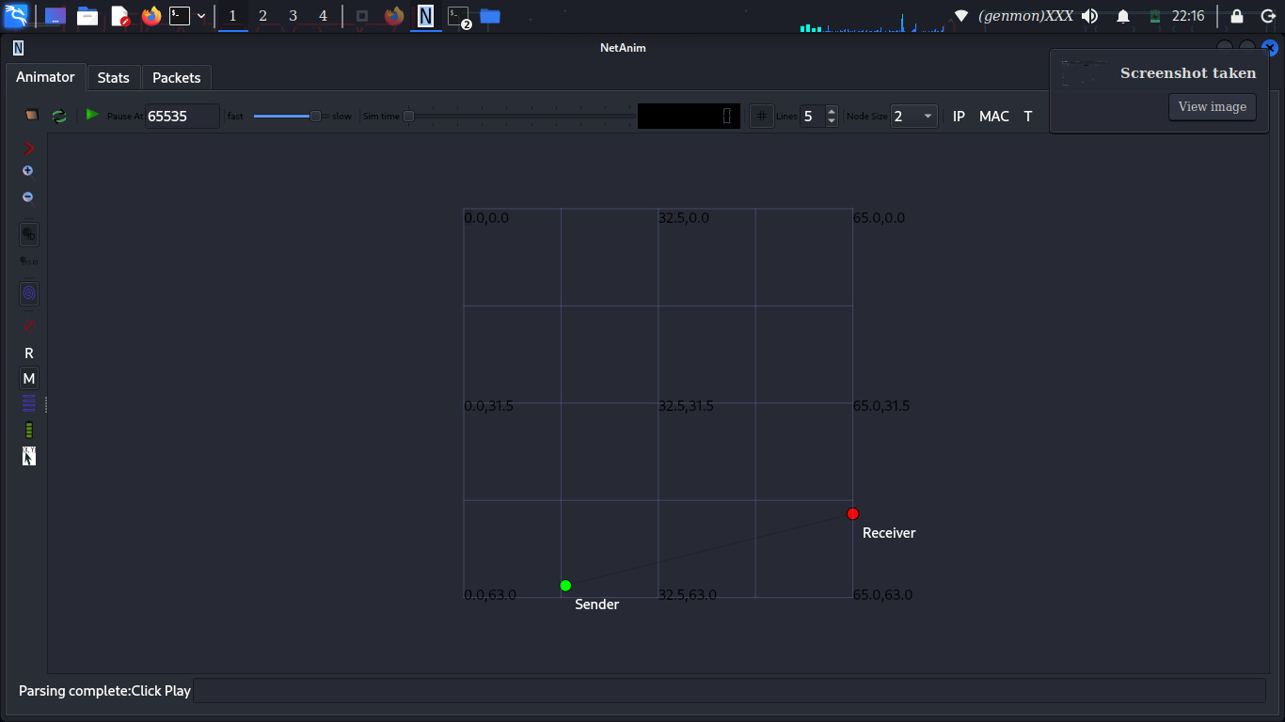

EXERCISE 4: Multi-Hop WAN with Fault Tolerance
Interpretation:

Traffic flows:

Branch → DC-A → DC-B

Backup link:

DC-A ↔ DC-B

Explanation

This exercise focuses on fault tolerance in a multi-hop WAN network. The objective is to observe how the network behaves when a critical link or router fails while traffic is flowing through multiple hops.

In this exercise, communication passes through more than one intermediate node. A failure is intentionally introduced on a main link to see whether traffic can still reach its destination. This helps demonstrate the difference between static routing, which does not automatically adapt to failures, and dynamic routing, which can find new paths.

The exercise shows that without adaptive routing, network communication can stop after a failure. It emphasizes the importance of fault-tolerant design and the use of dynamic routing protocols in large or critical networks.

Failure Simulation:
Simulator::Schedule(Seconds(5.0),
&Ipv4::SetDown, ipv4, interfaceIndex);

Result:
• Static routing → traffic stops
• Dynamic routing → reconverges

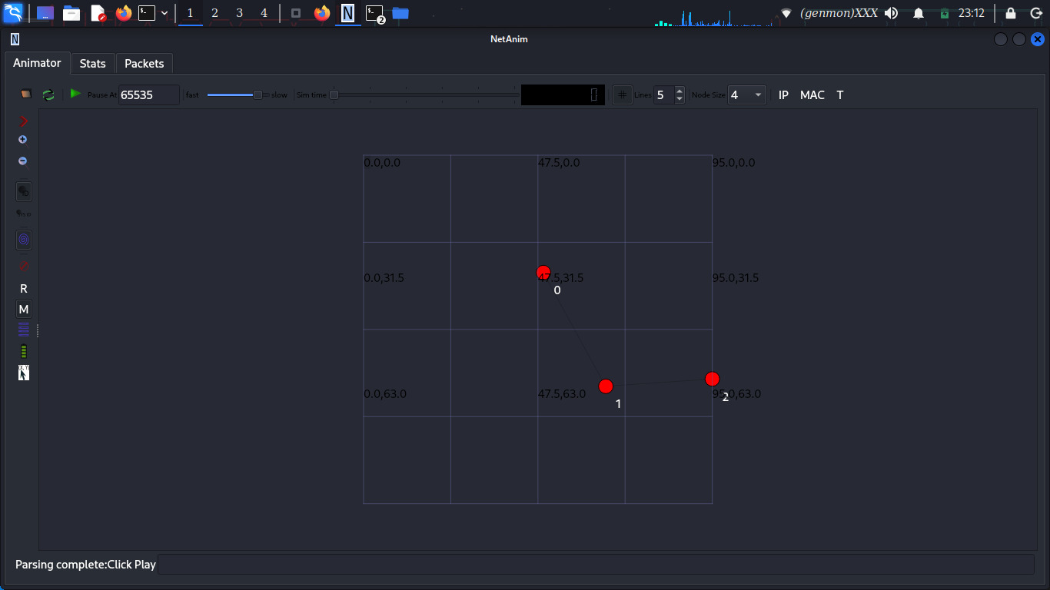

EXERCISE 5: Policy-Based Routing (PBR)
Interpretation:

Routing decisions depend on traffic type, not destination.

Logic:
• Video → low-latency path
• Data → high-bandwidth path

Pseudocode:
if (packet.port == VIDEO_PORT)
usePathA();
else
usePathB();

Metrics Source:
• FlowMonitor
• Ipv4L3Protocol trace hooks

Explanation

This exercise focuses on Policy-Based Routing (PBR) in a WAN environment. The goal is to route traffic based on defined policies rather than only on destination IP addresses.

In this exercise, different types of traffic are identified, such as video traffic and data traffic. Routing decisions are then made according to specific rules, for example sending video traffic through a low-latency path and data traffic through a high-bandwidth path. This allows the network to use its resources more efficiently.

The exercise highlights how modern networks can make intelligent routing decisions based on application requirements, improving performance, reliability, and user experience.

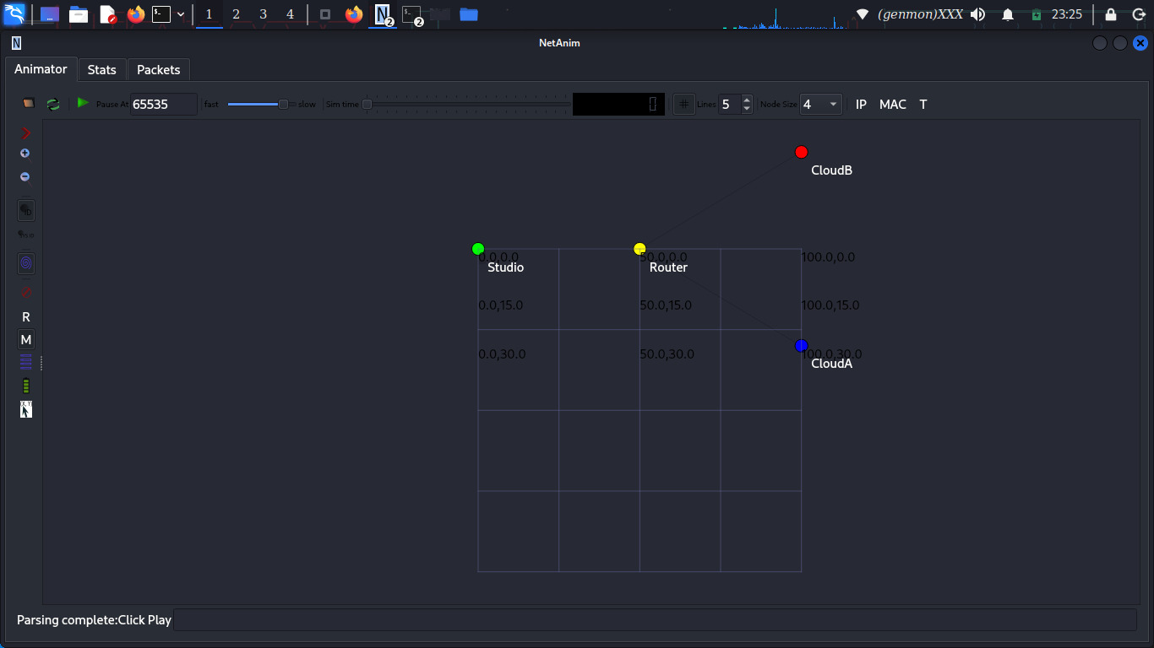

EXERCISE 6: Inter-AS Routing (BGP Concepts)
Interpretation:

NS-3 has no native BGP → model logical AS separation.

Explanation

This exercise focuses on inter-domain routing, which is how traffic is routed between different networks or Autonomous Systems (AS) on the Internet. It introduces the basic concepts behind the Border Gateway Protocol (BGP).

In this exercise, multiple networks are treated as separate autonomous systems, and routing decisions are made based on policies rather than just the shortest path. Factors such as preferred routes, network ownership, and path attributes influence how traffic is forwarded between domains.

The exercise shows that inter-domain routing is more complex than internal routing and highlights the limitations of simulation tools like NS-3 for full BGP implementation, while still helping to understand the core principles of Internet-scale routing.

AS Modeling:
• AS65001 nodes
• AS65002 nodes
• Exchange points as routers

BGP Attribute Simulation:
Attributes:
• AS_PATH (vector)
• LOCAL_PREF (integer)
• PREFIX (e.g., 192.168.0.0/16)

Decision Rule
Higher LOCAL_PREF → Shorter AS_PATH → Best route installed

Route Leak Simulation:
• Advertise internal prefix to external AS
• Observe incorrect path selection

Reality vs NS-3
NS-3 limitations:
• No real BGP FSM
• No route reflectors
• No communities

